Loyalty+ Store (Real Targets)
QA Test Report
Comprehensive Testing for SauceDemo Web UI & DummyJSON REST API

Prepared by: Muhammed Derar Marashdeh
Date: February 2026

Contents
- Executive Summary
  - Key Results
- System Under Test
  - SUT & Target URLs
  - Test Environment
  - Assumptions & Dependencies
- Test Strategy and Scope
  - In Scope (Web UI, API)
  - Out of Scope
  - Test Types & Approach
  - Test Design Techniques
- Manual Testing
  - Test Scenarios
  - Coverage & Execution Summary
- Defects and Findings
  - Defect Summary (Severity)
  - Key Issues (Highlights)
  - Detailed Examples (D-01, D-02, D-04)
- API Testing (Postman/Newman)
  - Collection Overview
  - Data/Environment Setup
  - Assertions & Checks
  - Newman Run Summary
- Performance Testing (k6)
  - Test Plan & Load Scenarios
  - KPIs & Thresholds
  - Results & Analysis
  - Recommendations
- UI Automation (Selenium + TestNG)
  - Automation Approach & Structure
  - How to Run
  - Results/Evidence
  - Maintainability Improvements
- Risks and Recommendations
  - Risks
  - Limitations
  - Recommendations
- Appendix
- Project Artefacts
- Evidence & Logs
- Command Reference

1. Executive Summary
This report summarises the end-to-end Quality Assurance work completed for the “Loyalty+ Store” capstone assignment. The objective was to validate a realistic retail journey across two targets: the SauceDemo (Swag Labs) web UI and the DummyJSON REST API.
Testing was performed using a blended approach: manual functional testing, automated API testing (Postman/Newman) with data-driven iterations, basic API performance planning using k6, and UI automation using Selenium WebDriver with TestNG.

Key Results (High Level)
Manual test cases executed | 23
Manual pass / fail | 15 passed / 8 failed (pass rate: 65%)
Defects / findings logged | 8 (from failed manual cases)
API automation (Newman) | 29 requests executed over 9 data-driven iterations (261 total requests); 927 assertions; 0 failed tests
Newman timings | Total duration 59.1s; average response time 140ms
UI automation | 8 end-to-end UI tests implemented in Selenium + TestNG

Overall, the DummyJSON API behaved consistently during the automated run with all assertions passing. For the SauceDemo UI, most workflows passed under the standard_user account, while additional accounts (problem_user, error_user, visual_user, performance_user) exposed multiple issues. These issues were documented as defects/test findings with severity ratings and reproduction steps.

2. System Under Test and Assumptions

2.1 System Under Test (SUT)
The Loyalty+ Store project is treated as a retail platform with two real testing targets:
- Web UI: SauceDemo (Swag Labs) – an e-commerce demo site used to validate login, product browsing, cart management, and checkout.
- Backend REST API: DummyJSON – a public practice API used to validate authentication, products, carts, and users endpoints.

Target URLs
SauceDemo UI | https://www.saucedemo.com
DummyJSON API | https://dummyjson.com

2.2 Test Environment
Operating System | Windows 11 Pro
CPU / RAM/GPU | Intel Core i7-13650HX @ 2.60GHz / 16 GB/Nvidia Geforce RTX5060
Browsers | Chrome 144.x (64-bit), Firefox 147.x (64-bit)
Tools | Postman + Newman, k6, Selenium WebDriver, Maven, TestNG, Git/GitHub

2.3 Assumptions and Dependencies
- SauceDemo and DummyJSON remain available and reachable during the testing window.
- Test data is non-production and may reset periodically; tests should not rely on persistent created records.
- Pre-defined test accounts are available for SauceDemo (e.g., standard_user, problem_user, visual_user, performance_user, error_user).
- API authentication tokens are valid for subsequent requests and can be stored in environment variables for re-use.
- No real personal or payment data is used; only fake test data is entered, following the rules of engagement in the assignment brief.

3. Test Strategy and Scope

3.1 Scope (In-Scope)

Web UI (SauceDemo)
- Authentication: valid/invalid login and logout
- Product browsing: view inventory, open product details, sorting and filtering (where available)
- Shopping cart: add single and multiple items, remove items, continue shopping
- Checkout: customer information form, overview, and completion
- UI/UX checks: layout, responsiveness, visibility of labels/images/buttons, and error messages

REST API (DummyJSON)
- Authentication: POST /auth/login and token handling (plus refresh token handling where available)
- Products: list, get by ID, search queries, create/update/delete operations (as supported by the demo API)
- Carts: list, get by ID, get by user, create/update/delete operations (as supported)
- Users: list, get by ID, search queries
- Data integrity: response schema/required fields, data types, and basic validation
- Error handling: correct HTTP status codes and informative error messages
- Authorization: token validation for protected endpoints

3.2 Out-of-Scope
- Mobile app testing (optional in the assignment and not implemented in this submission)
- Deep security testing (e.g., scanning, brute force, exploitation) – excluded by the rules of engagement
- Database-level validation (only validated via UI/API responses)
- Real payment gateway integration (SauceDemo uses demo checkout)

3.3 Test Types and Approach
- Smoke testing to confirm basic availability and critical path flows
- Functional testing with positive and negative scenarios
- API automation in Postman with reusable environments, variables, and assertions
- Data-driven API coverage using CSV iterations
- Performance test planning using k6 (smoke + load profiles, thresholds, and KPIs)
- UI automation using Selenium WebDriver + TestNG for critical end-to-end scenarios

3.4 Test Design Techniques
- Equivalence Partitioning and Boundary Value Analysis for form inputs and API parameters
- State transition testing for cart and checkout workflows
- Risk-based prioritisation using different SauceDemo user accounts (standard, problem, performance, visual, error)

4. Manual Testing

4.1 Manual Test Scenarios
Manual testing focused on validating the complete retail journey on SauceDemo (login → browse → cart → checkout → logout), with additional negative and exploratory checks using special SauceDemo accounts that intentionally expose issues.
- Login using valid credentials (standard_user) and verify successful navigation to the inventory page.
- Attempt login using invalid credentials and verify the correct error message is shown.
- Add a single item and multiple items to the cart; verify the cart badge count and item details.
- Remove items from the cart and verify the cart badge updates correctly.
- Validate product sorting by name and by price.
- Continue shopping from the cart and verify the user returns to the inventory list.
- Complete the checkout process (customer information → overview → finish) and verify the confirmation message.
- Verify product details page content (name, price, description, image) and add-to-cart from the details page.
- Reset application state and confirm the cart is cleared.
- Perform visual and performance observations using visual_user and performance_user accounts.

4.2 Coverage Overview
A total of 23 manual test cases were designed and executed. The table below summarises coverage by feature area.
Feature Area | Total Cases | Passed | Failed
Authentication | 3 | 3 | 0
Cart | 5 | 3 | 2
Checkout | 6 | 3 | 3
Performance | 1 | 0 | 1
Product Details | 3 | 2 | 1
Product Listing (Sorting) | 3 | 2 | 1
State Management | 1 | 1 | 0
UI/Visual | 1 | 0 | 1

4.3 Execution Summary
Total executed | 23
Passed | 15
Failed | 8
Pass rate | 65%
Evidence | Screenshots and evidence links were captured per test case (see Appendix).

Execution by Account
Account | Total | Passed | Failed
error_user | 1 | 0 | 1
performance_user | 1 | 0 | 1
problem_user | 4 | 0 | 4
standard_user | 16 | 15 | 1
visual_user | 1 | 0 | 1

Manual Execution Chart
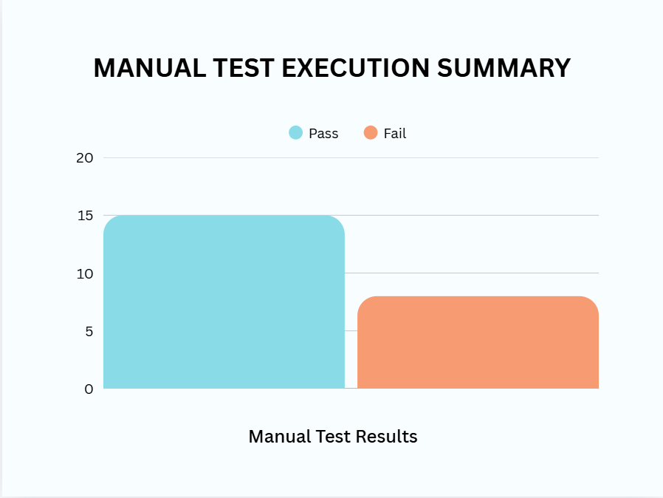

5. Defects and Test Findings

5.1 Defect Summary
During manual execution, 9 test cases did not meet the expected results and were logged as defects/test findings. Most of these findings were discovered using non-standard SauceDemo accounts (problem_user, error_user, performance_user, visual_user), which are designed to demonstrate different classes of issues (functional, visual, and performance).
Severity | Number of Defects
CRITICAL | 2
HIGH | 2
MEDIUM | 4

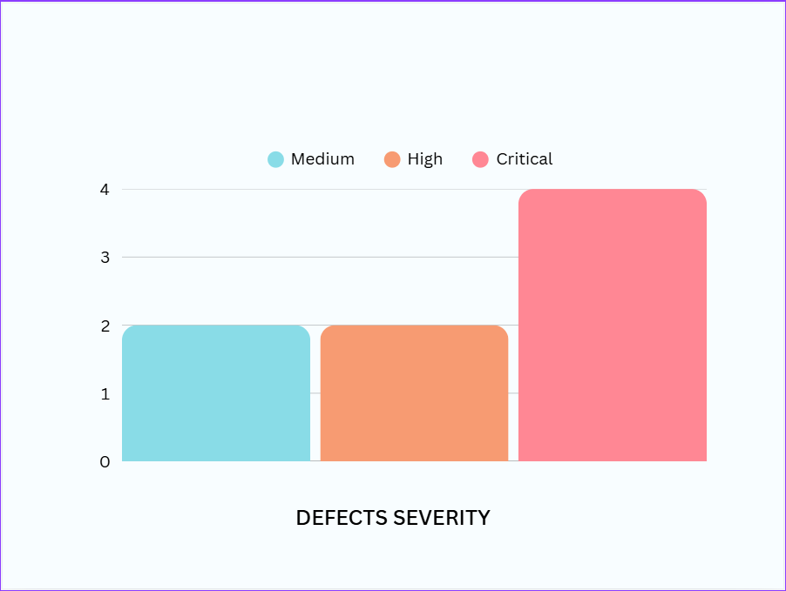
Severity Distribution Chart

5.2 Top Issues (Examples)
The table below lists the main issues with a short summary. Detailed reproduction steps are provided for the highest-impact issues.
Defect ID | Severity | Area | Account used | Short Title | Impact
D-01 | CRITICAL | Checkout | error_user | Last Name Field Not Accepting Input | Last name doesn’t accept input
D-02 | HIGH | Product Listing (Sorting) | problem_user | Sorting Functionality Broken | Sorting functionality is not working
D-03 | CRITICAL | Checkout | problem_user | Checkout Process Fails | Last name field does not accept input whatever the clicked letter i...
D-04 | MEDIUM | UI/Visual | visual_user | Visual Rendering Issues | Allignment issues appear items are not properly located
D-05 | MEDIUM | Performance | performance_user | Extremely Slow Page Loads | Page take longer time to load
D-06 | MEDIUM | Product Details | problem_user | Incorrect Product Images Displayed | Displayed product image does not match the product name/description
D-07 | HIGH | Cart | problem_user | Remove Button Not Working (Item stays in c... | Remove button is not clickable / item is not removed; cart badge do...
D-08 | MEDIUM | Checkout | standard_user | Checkout Allowed with Empty Cart | User can proceed to checkout information page even when cart is empty

5.3 Detailed Defect Examples

D-01: Last Name Field Not Accepting Input
Severity | CRITICAL
Affected area | Checkout
Account used | error_user
Related test case | Test Case 16

Steps to Reproduce:
1. Login as error_user
2. Add product to cart
3. Go to checkout
4. Enter firest name
5. Try to enter last name

Expected Result:
Last name accepts input

Actual Result:
last name doesn’t accept input

D-03: Checkout Process Fails
Severity | CRITICAL
Affected area | Checkout
Account used | problem_user
Related test case | Test Case 18

Steps to Reproduce:
1. Login as problem_user
2. Add products to cart
3. Click checkout
4. Fill form and submit
5. Click finish

Expected Result:
checkouut completes and confirmation displays

Actual Result:
last name field does not accept input
whatever the clicked letter is , it gets displayed in first name field

6. API Testing (Postman/Newman)

6.1 Collection Design
API testing targeted the DummyJSON REST API. A Postman collection (“FinalProjectApiTest”) was designed with modular folders to keep related requests together and to support reuse of variables and shared assertions.
Folder | Number of Requests
Authentication | 3
Carts | 6
HealthCheck | 1
NegativeCases | 3
Products | 10
Users | 6

Key request groups included:
- HealthCheck: basic connectivity check (GET /test).
- NegativeCases: invalid product ID (404) and boundary/edge cases for add operations.
- Authentication: login (POST /auth/login), current user (GET /auth/me), refresh (POST /auth/refresh).
- Products: list, get-by-id (data-driven), search, categories, create/update/delete operations.
- Carts: list, get-by-id, get-by-user, create/update/delete operations.
- Users: list, search, create user, and related resources (carts/posts/todos).

6.2 Environment and Data-Driven Testing
A dedicated Postman environment (“DummyJson”) was created to externalise configuration and test data. Key variables included:
- BaseUrl (https://dummyjson.com)
- username / password (used for /auth/login)
- AccessToken and RefreshToken (captured from the login response)
- UserId, ProductId / productId, CartId (used across requests)
Data-driven execution was implemented using a CSV file (products_datadriven.csv). Each iteration supplies a productId (and expectedStatus) to validate the “GetSingleProduct” request over multiple products.

6.3 Key Assertions and Checks
- HTTP status code validations (e.g., 200/201 for success, 404 for invalid product ID).
- Response time checks (most requests assert a response time target such as <500ms or <1500ms).
- Content-Type validation (application/json).
- Schema/field checks for critical objects (e.g., id, username, email, accessToken, refreshToken).
- Token extraction and re-use via environment variables and/or cookies (DummyJSON returns an accessToken cookie on login).

6.4 Newman Automated Run Summary
The collection was executed via Newman using the following command (data-driven run + HTML report):
newman run FinalProjectApiTest.json -e DummyJson.postman_environment.json -d products_datadriven.csv -r htmlextra --reporter-htmlextra-export newman-report.html
Run date/time (from report) | Sunday, 25 January 2026 21:19:22
Total iterations | 9
Total requests | 261
Total assertions | 927
Failed tests | 0
Average response time | 140ms
Total run duration | 59.1s
Total data received | 1.73MB
Result: All API tests passed in the documented run (0 failed tests, 100% pass percentage). This indicates that the collection assertions were stable and the API responses were consistent for the tested endpoints and datasets.
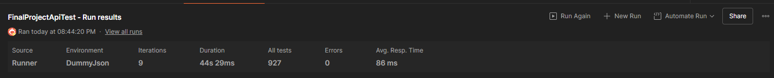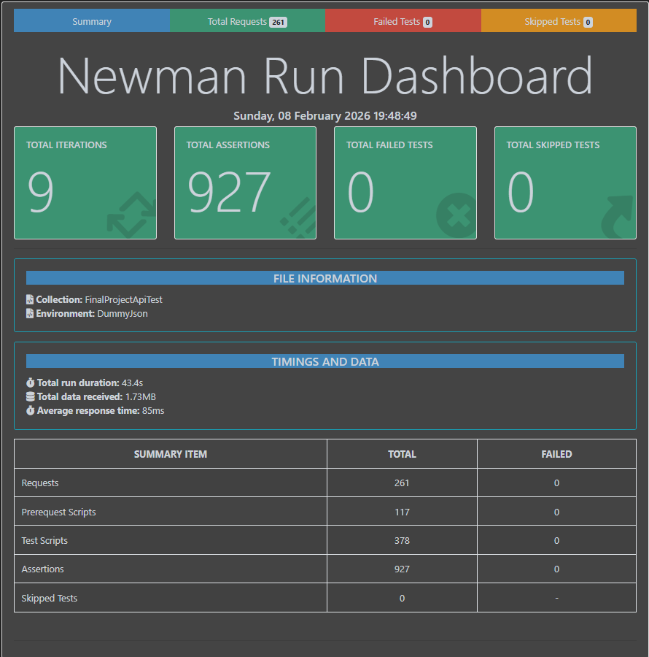

7. Performance Testing (k6)

7.1 Performance Test Plan
API performance testing was planned using k6 to evaluate response time, stability, and error rate for core product endpoints. The k6 script (K6Testing.js) targets three endpoints on DummyJSON:
- GET /products/categories (categories details)
- GET /products/category-list (category names)
- GET /products/category/{CATEGORY} (products by category; default CATEGORY=smartphones)

7.2 Load Profiles and Scenarios
The script is structured as separate scenarios per endpoint. For each endpoint, two profiles are executed:
- Smoke/Light: 5 virtual users (VUs) for 10 seconds
- Load/Heavier: 25 VUs for 45 seconds
Scenarios are staggered in time to avoid overlapping heavy loads and to make analysis clearer. The following chart illustrates the planned VU ramp over the full test duration.
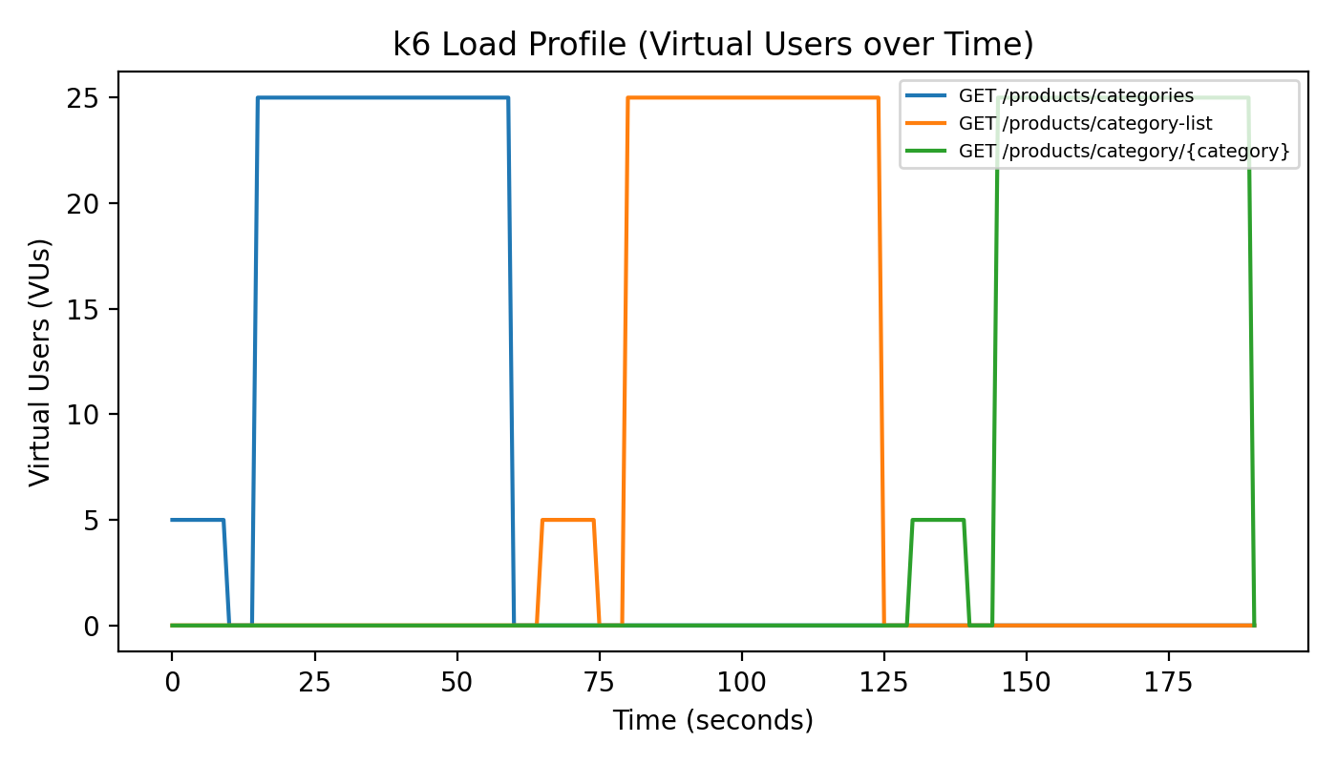

Scenario Schedule (from script)
Endpoint | Start Time | Duration | VUs
GET /products/categories | 0s | 10s | 5
GET /products/categories | 15s | 45s | 25
GET /products/category-list | 65s | 10s | 5
GET /products/category-list | 80s | 45s | 25
GET /products/category/{CATEGORY} | 130s | 10s | 5
GET /products/category/{CATEGORY} | 145s | 45s | 25

7.3 KPIs and Thresholds (Acceptance Criteria)
The script defines strict thresholds to act as Service Level Objectives (SLOs). A run is considered acceptable when these thresholds are met.
Metric | Target | Notes
http_req_failed | < 0.5% (rate < 0.005) | Error budget across all requests
http_req_duration p(90) | < 500 ms | Overall latency SLO
http_req_duration p(95) | < 800 ms | Overall latency SLO
http_req_duration p(99) | < 1200 ms | Overall latency SLO
http_req_duration p(99.9) | < 1800 ms | Tail latency SLO
http_req_duration max | < 2500 ms | Hard cap to catch outliers

7.4 Execution Instructions
To run the performance test locally:
1. Install k6 on your machine.
2. From the project folder, run:
k6 run -e BASE_URL=https://dummyjson.com -e CATEGORY=smartphones K6Testing.js

7.5 Results and Analysis

This section documents the actual k6 execution results for the three targeted DummyJSON endpoints (categories details, category names, and products by category) under both smoke and load profiles.

Execution Summary
- Total runtime: 3m11.1s
- Scenarios executed (sequentially):
  - categories_details_5vus → 5 VUs for 10s
  - categories_details_25vus → 25 VUs for 45s
  - category_names_5vus → 5 VUs for 10s
  - category_names_25vus → 25 VUs for 45s
  - products_by_category_5vus → 5 VUs for 10s
  - products_by_category_25vus → 25 VUs for 45s
- Max concurrent VUs observed: 25 (the script’s vus_max was 55, but scenarios were staggered, so they did not overlap)
- Total iterations / requests: 3,088
- Throughput: ~16.16 requests/second
- Network usage: 31 MB received, 307 kB sent

Correctness and Stability (Checks + Error Rate)
- Checks executed: 18,528
- Checks passed: 100% (18,528 / 18,528)
- HTTP request failures: 0.00% (0 / 3,088)
- This confirms that under load, the API responses remained functionally correct and stable, with no failed validations.
Key validations included:
- Response status is 2xx
- Response time < 1500ms
- Response is JSON
- Array structure and non-empty responses
- Required category fields exist (slug, name, url)
- Category list contains strings only
- Products response contains products[] and all items match the requested category

Latency Results (Overall)
Overall request timing (http_req_duration) was strong and comfortably within all thresholds:
Metric | Result
Average | 155.57 ms
Median | 143.62 ms
p90 | 152.39 ms
p95 | 251.28 ms
p99 | 408.53 ms
p99.9 | 661.71 ms
Max | 847.30 ms
Threshold validation (overall):
All defined SLOs passed: p90<500, p95<800, p99<1200, p99.9<1800, max<2500.

Endpoint-Level Summary
The endpoint-specific custom trends show consistent performance across all three APIs:

Endpoint Trend | Requests | Avg | p95 | p99 | p99.9 | Max
categories_details_duration | 1033 | 156.02 ms | 260.09 ms | 414.73 ms | 678.18 ms | 847.30 ms
category_names_duration | 1031 | 153.09 ms | 223.68 ms | 508.09 ms | 657.59 ms | 661.95 ms
products_by_category_duration | 1024 | 157.63 ms | 274.05 ms | 405.99 ms | 417.48 ms | 538.22 ms

Threshold validation (per endpoint):
- All p95/p99/p99.9/max thresholds were met for every endpoint.
- Notably, even the slowest observed request (847ms) was still far below the maximum allowed threshold (2500ms for overall and categories, 3000ms for products-by-category).

Interpretation and Analysis
- Performance is healthy with strong headroom.
p95 stayed between ~224ms and ~274ms, which is far below the acceptance criteria (800–900ms).
- Tail latency exists but is controlled.
p99.9 values peaked around ~662ms, and max peaked at 847ms, suggesting occasional slower responses (normal on public demo APIs due to shared traffic), but still well within limits.
- No rate limiting or instability was observed in this run (0 failures), which is a good sign that the load profile used was respectful and that the endpoint handled it reliably.
- Throughput is moderate by design because the script includes a sleep(1) delay per iteration, which reduces request pressure and better simulates user pacing.

Recommendations and Next Steps
Even though all thresholds passed, the following would strengthen the performance evidence if this were a production-like system:
- Run a longer load test (10–15 minutes) to validate stability over time.
- Add a mixed-traffic scenario (hit endpoints concurrently) to observe contention effects.
- Add a step/ramp test (e.g., 10 → 25 → 40 VUs) to find the saturation point and measure graceful degradation.
- If testing a real backend, collect server-side monitoring (CPU/memory/DB/APM) to identify bottlenecks behind tail latency.
Conclusion:
Based on the provided k6 run, the DummyJSON product endpoints meet the defined performance acceptance criteria for both smoke and load profiles (up to 25 VUs), with 0% failures and strong latency margins.

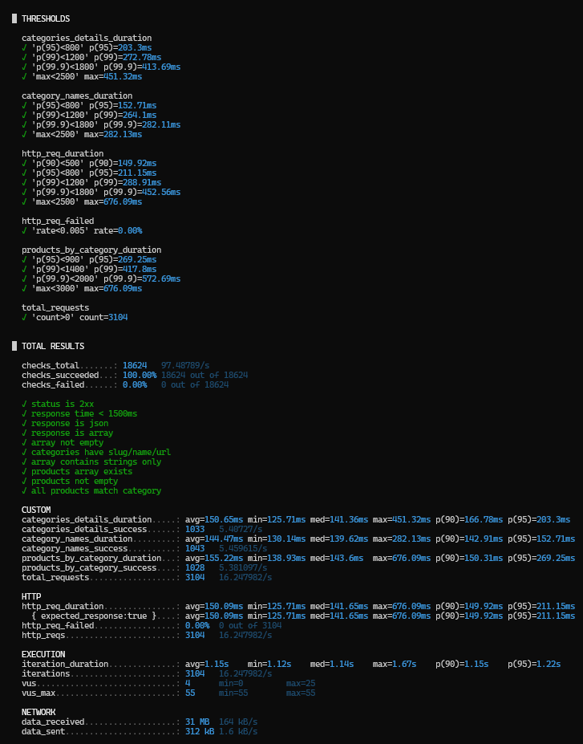

8. UI Automation (Selenium + TestNG)

8.1 Automation Approach
UI automation was implemented for the SauceDemo web application using Selenium WebDriver with Java and TestNG. The goal was to automate critical end-to-end user workflows to support quick regression checks, especially around login, cart operations, and checkout.
- Framework: Java + Selenium WebDriver + TestNG, built and executed with Maven.
- Browser: Firefox (via Selenium 4 driver management).
- Execution style: sequential tests with TestNG priorities to follow a realistic shopping flow.
- Assertions: TestNG assertions validate navigation, cart contents, sorting, and checkout totals.

8.2 Test Suite Structure
The suite is implemented in SauceDemoTests.java and contains eight prioritised test methods:
Priority | Test Method | Purpose (high level)
1 | LoginTest | Login with standard_user and verify inventory page loads
2 | AddOneItemToCart | Add a single product to cart and verify cart badge and contents
3 | ResetAppState | Reset app state and confirm cart is cleared
4 | SortProductsByPrice | Change sort to Price (low to high) and validate ordering
5 | SelectMultipleProducts | Add multiple products and confirm cart count and selected items
6 | checkout_goToOverview | Enter checkout information and proceed to overview page
7 | VerifyTotalPrice | Validate total price calculation and complete purchase
8 | BackToHomePageAndLogout | Return to inventory and log out

8.3 How to Run
Prerequisites:
- Java JDK installed (project is configured for JDK 25 in pom.xml).
- Maven installed (or use the Maven wrapper if included).
- Firefox installed.
Run commands (from the project root):
mvn clean test
Optional: run only this class:
mvn test -Dtest=SauceDemoTests

8.4 Sample Results and Evidence
When executed successfully, Maven Surefire/TestNG generates reports under target/surefire-reports (and console output shows the run summary). As an example, a typical successful Maven output line is:
Tests run: 8, Failures: 0, Errors: 0, Skipped: 0

Recommended improvements for maintainability:
- Refactor to Page Object Model (POM) to reduce duplication and improve readability.
- Replace implicit waits with explicit waits for better stability on slow environments.
- Externalise credentials and base URL into a properties file.
- Integrate reporting (e.g., Allure) and CI execution (GitHub Actions).

9. Risks, Limitations, and Recommendations

9.1 Key Risks
- External dependency risk: SauceDemo and DummyJSON are public demo systems; availability, performance, and data can change without notice.
- Rate limiting / shared traffic: DummyJSON responses include rate-limit headers; heavy testing may trigger throttling or increased latency.
- Test data volatility: created resources may not persist between runs, and demo data may reset.
- Workflow dependency: UI automation follows a sequential flow; failures early in the chain can block later tests.

9.2 Limitations
- Performance testing results were not captured in an attached k6 output log; only the plan, script, and thresholds are documented here.
- Mobile automation was not implemented (optional/advanced component).
- Security testing was intentionally excluded per the assignment rules of engagement.
- UI automation is implemented in a single test class without Page Object Model, which limits maintainability as the suite grows.

9.3 Recommendations
- Add CI execution (GitHub Actions) to run Newman, UI automation, and k6 smoke tests on every push.
- Expand API negative testing (validation errors, missing auth, invalid payloads) and add schema validation for critical endpoints.
- Capture k6 results into a JSON summary and convert key metrics into charts for the final report.
- Improve UI automation maintainability with POM and add automatic screenshots on failure.
- Introduce tagging and test grouping (smoke/regression) to support selective execution.

10. Appendix

10.1 Project Artefacts (Files)
The following key files were included in the project package:
- TEST PLAN.docx – test plan, scope, and risks.
- Test-Cases.xlsx – manual test cases with expected/actual results and evidence references.
- FinalProjectApiTest.json – Postman collection.
- DummyJson.postman_environment.json – Postman environment variables.
- products_datadriven.csv – CSV data for Newman data-driven iterations.
- newman-report.html – HTML Newman report output (htmlextra reporter).
- K6Testing.js – k6 performance test script (smoke + load profiles).
- SauceDemoTests.java – Selenium + TestNG UI automation suite.
- README.md – setup and execution notes for UI automation.

10.2 Evidence and Logs
Manual testing evidence is referenced per test case in the “Evidence” column of Test-Cases.xlsx. The Newman HTML report (newman-report.html) contains request/response logs, timings, and assertion outcomes for the API run.

10.3 Quick Command Reference
API Testing (Newman):
newman run FinalProjectApiTest.json -e DummyJson.postman_environment.json -d products_datadriven.csv -r htmlextra --reporter-htmlextra-export newman-report.html
Performance Testing (k6):
k6 run -e BASE_URL=https://dummyjson.com -e CATEGORY=smartphones K6Testing.js
UI Automation (Maven):
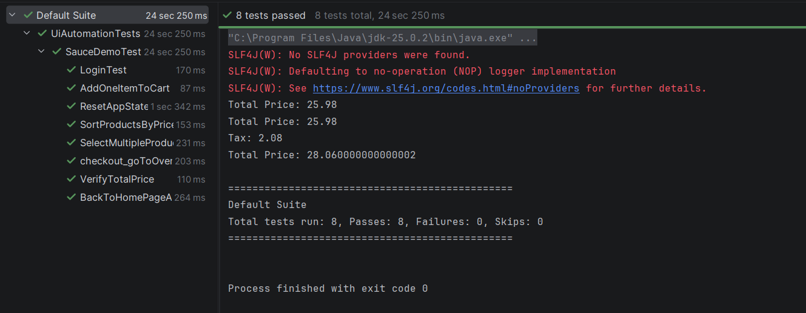
mvn test -Dtest=SauceDemoTests

